Project Design Phase
Solution Architecture
Date | 8 October 2026
Student Name | OviyaShree
Project Name | Metro Ticket Generating System in ServiceNow
Maximum Marks

Solution Architecture
The architecture connects the passenger-facing booking experience with ServiceNow catalog configuration, validation rules, fare logic, QR code generation and the backend ticket and station data.
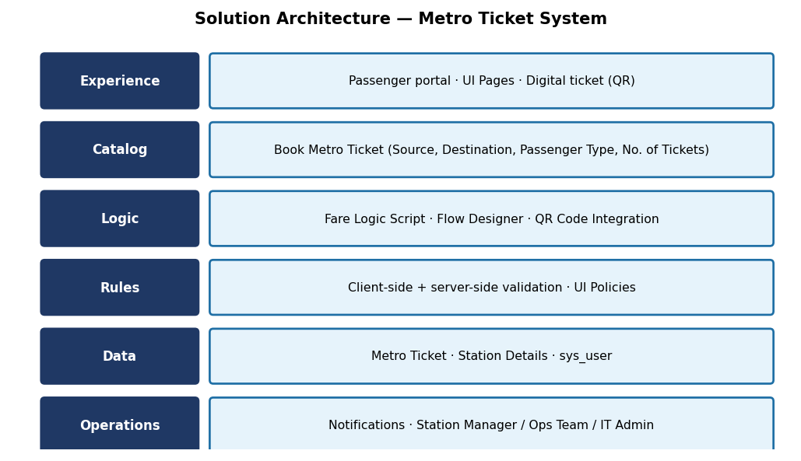
Figure 1: Metro Ticket solution architecture.
Layer | Components | Responsibility
Experience | UI Pages, passenger portal | Passenger UI.
Catalog | Book Metro Ticket item | Collect Source, Destination, Passenger Type, Number of Tickets.
Logic | Fare Logic Script, Flow Designer, QR Code Integration | Calculate fare and generate ticket.
Rules | Client/server validation, UI Policies | Validate and control fields.
Data | Metro Ticket, Station Details, sys_user | Persist records.
Operations | Notifications | Inform passengers and staff.
Data Architecture
Data architecture is the blueprint for how data is collected, stored, managed, integrated, and used across an organization. It defines the policies, standards, models, and rules that govern how data flows and supports business objectives.
Validation & Data Handling
Item | Description
Field validations | Non-empty source/destination, fare match, approved travel date.
Mandatory fields | Enforced on client and server side to prevent incomplete submissions.
Auto-populate logic | Default values (e.g., single, return journey) using catalog client scripts and UI policies.
Fields mapping | Process Automation Engine auto-maps fields and populates the values given by the user/clients.

